**SRS**

PURPOSE:

The project is regarding a Ecommerce Website of Electronic Gadgets . The purpose behind developing this website is to fulfil all the needs of the customers related to the mobile gadgets. This website would help the customers to buy, sell, review and compare the electronic gadgets. The customers would not have to visit different websites for purchasing the gadgets and comparing them with other gadgets to know which one is the best and deciding which one to buy because this website has it all.

My vision is that all people should have it as easy as possible to get access to all electronic gadgets.

SCOPE:

The website can be used by any age groups. The website has functionality of buying the mobiles, adding mobiles to the cart, checking orders. In future it would also include the functionality of comparing the products then and there only. It would have functionality of find in store with the help of which one can find the mobiles in offline stores. The website has functionality for admin to see the various graphs related to the products, orders and users in his dashboard.

FUNCTION:

There are various functionalities in the website

1. Purchasing Product
2. Adding Mobile, Editing Info Related to Mobiles
3. Adding, Viewing and Removing Orders
4. Adding Mobiles to Cart, viewing cart and deleting products from cart.
5. Adding new Users by admin or signup directly by end users.
6. Adding new Products to the Website, viewing products.
7. Adding Vendors
8. Managing User Roles and their privileges
9. Choosing mobile by category

When a user will visit the website he/she will be directed to the homepage, where he/she will have the option to sign up or login into the website or directly just see the products according to the different categories. But when the user will want to buy anything he/she would have to login or sign up to complete the further formalities.

SOFTWARE REQUIREMENTS:

Software Requirement:

* Apache
* PHP
* MySql
* Xampp
* Laravel Framework

MODULES:

1. Homepage:
2. The homepage of My Website contains the category according to which one can select the products. For now my website has only mobiles in the categories but after sometime I wish to include other electronic gadgets also to these categories. The homepage also shows the newest products that have been added . The homepage also has the logo of My website. It also has an option using which one can login or signup on the website.

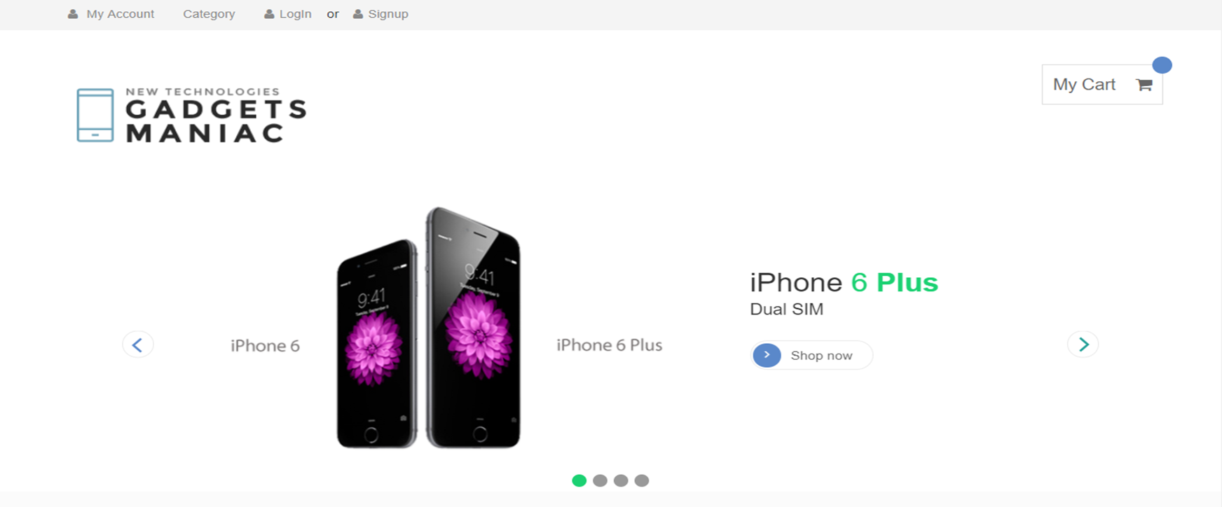

2.Login Page and Sign Up Page :

* The Login Page contains two fields username and password along with their validations . It also contains an link using which we can redirect to the signup page if the user is new.
* The signup page contains different fields like Email, Mobile Number , Name ,Password along with the validations . All the data is then added to the database if the validations are correct.

Login Page Snapshot

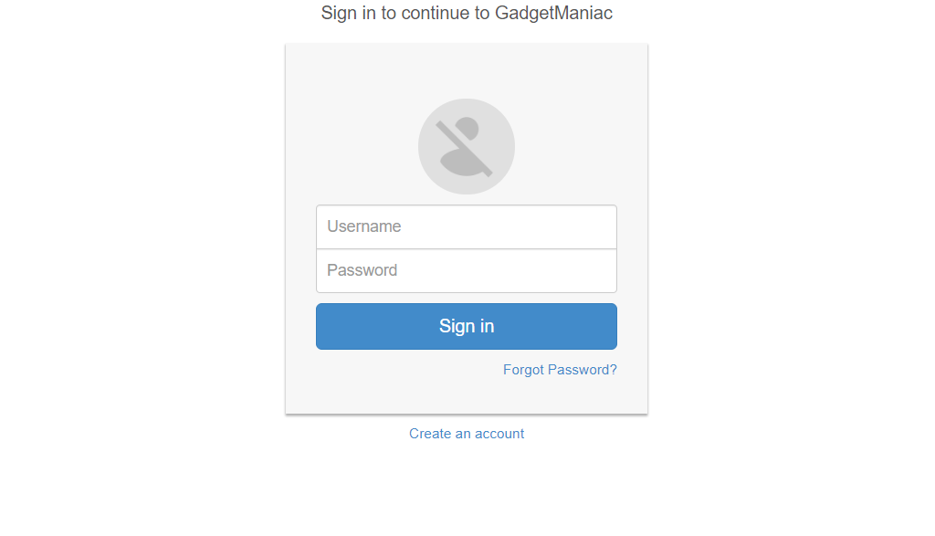

Snapshot Of Signup Page

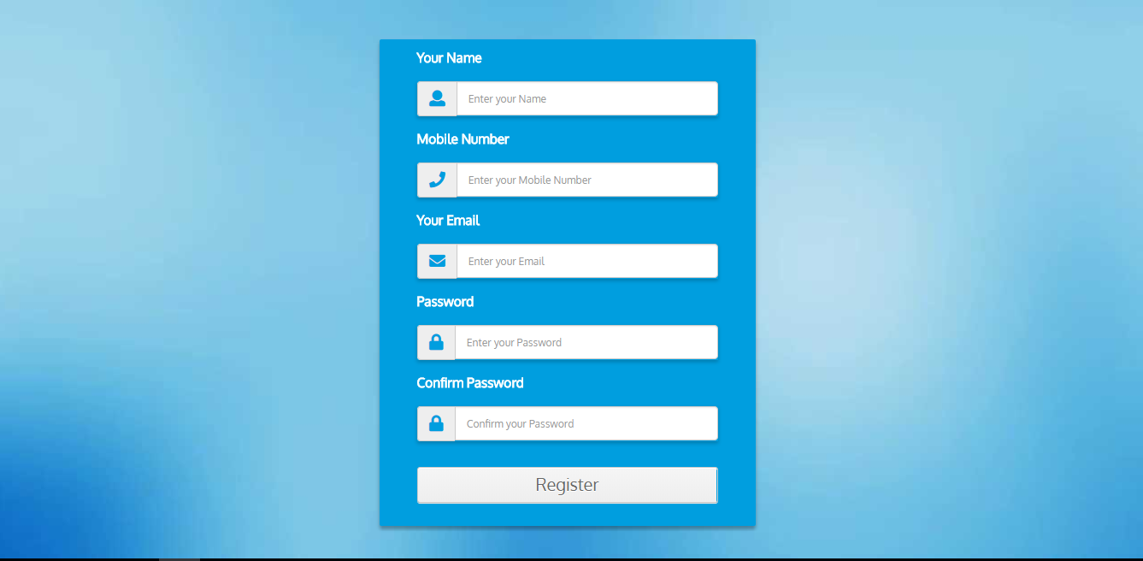

1. Admin Dashboard Page:

* This page belongs to admin. This page has functionalities using which the admin can add new products to the database, view the existing products, view all the employees that are present as well as view the end users and see their orders and status of the orders. The admin can add new vendors, view the vendors. The admin can assign roles to different users and assign them the privileges according to which they can perform the functions.
* The admin can see various graphs related to the products, orders and users like in which month how many users have been added, how many orders have been place, he can see how many products per brand has been placed etc.

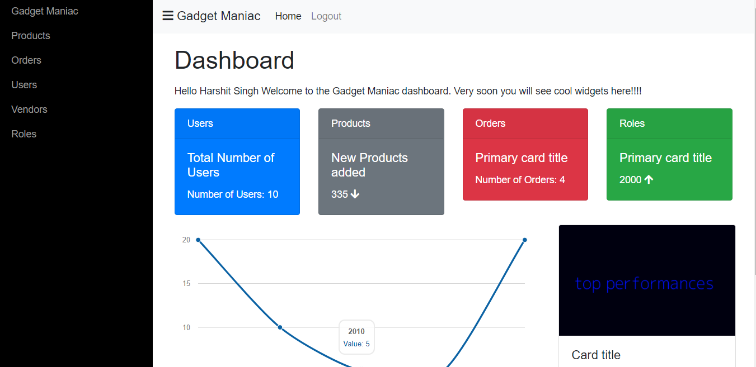

1. Category Page:

This page includes the different types of category according to which my phones can be selected. For now, on I am classifying my mobile phones on the basis of different brands that are present, but in future the classification will also include 4G enabled, GSM etc.

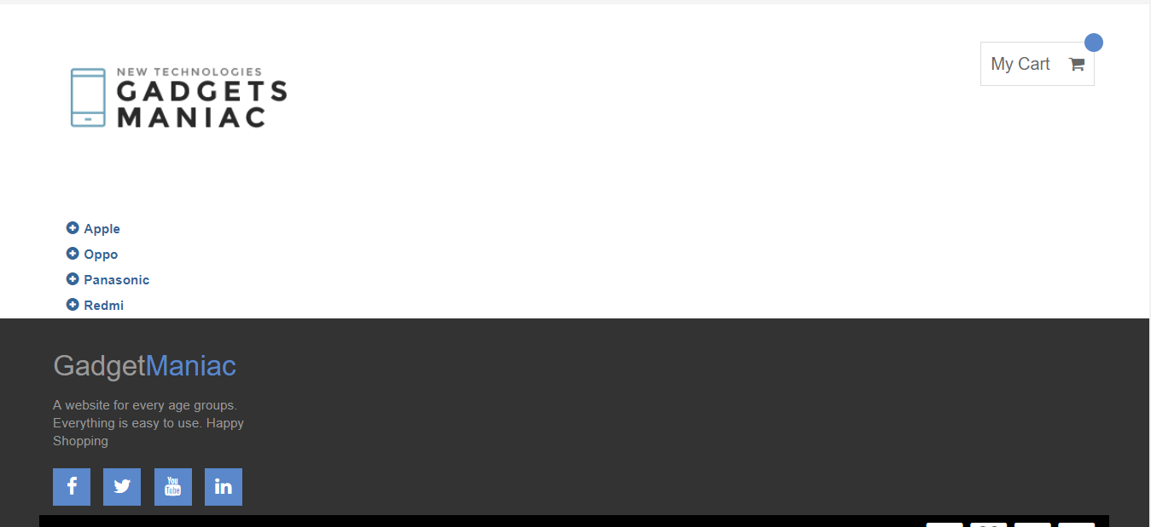

1. Shop Page:

This page contains details regarding the particular product that we want to buy. It has the image of the mobile along with other details such as camera features, memory features, connectivity features, display features, operating system and processing features. This page also contains the reviews of the end users.

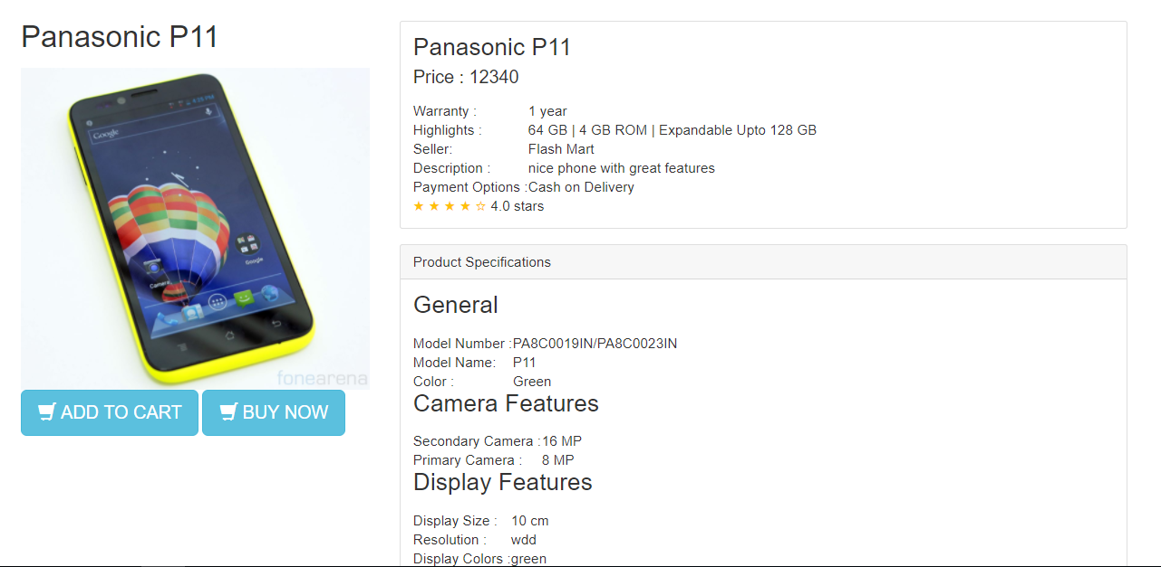

1. Checkout Page:

This page contains the order details like the order quantity, the price of the order, product description and other details. It also allows the user to select his/her shipping address, or add his/her shipping address if he/she does not have it. It also allows the user to select the payment mode.

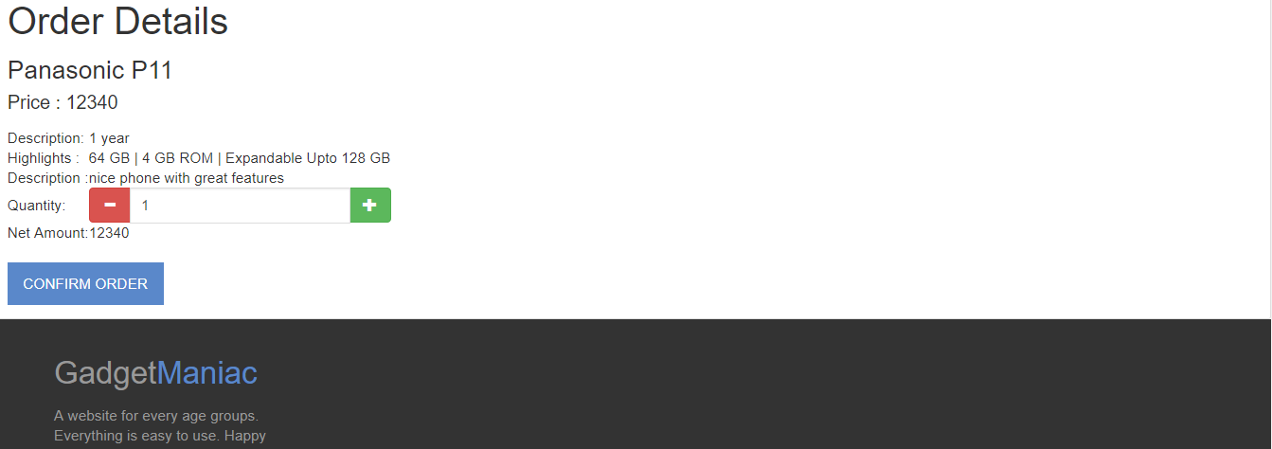

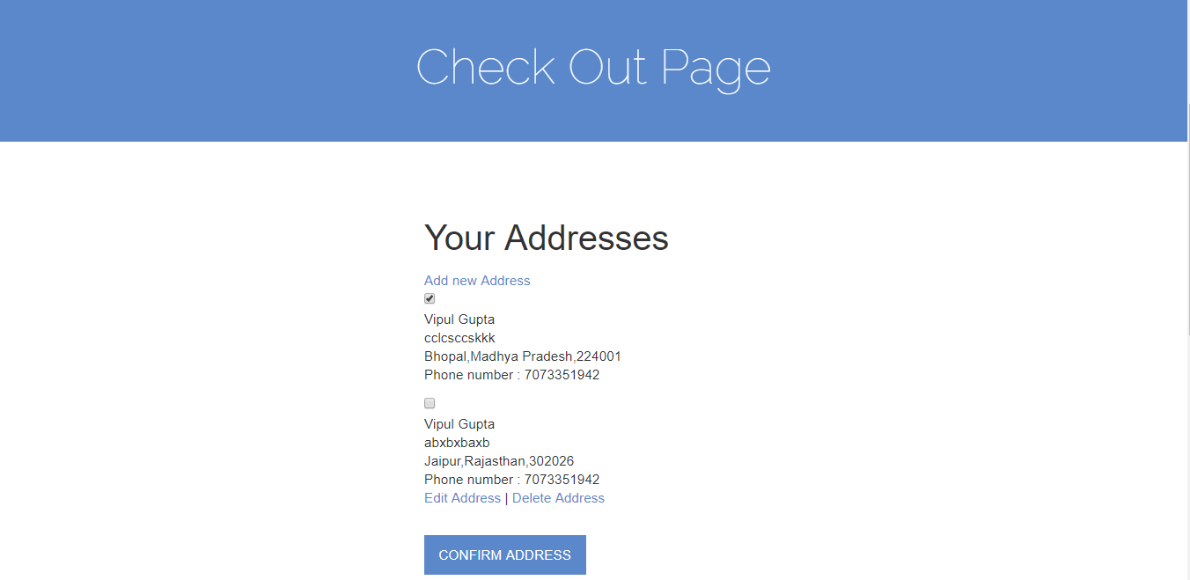

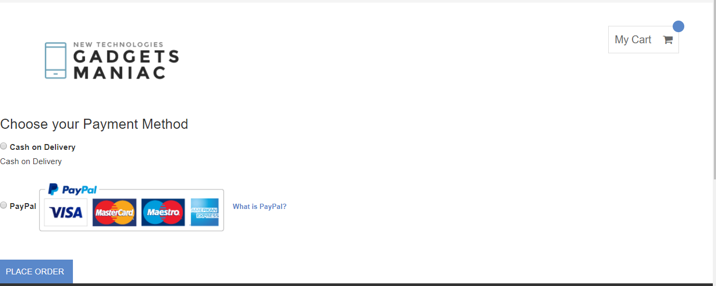

8.Order Summary Page : This page Contains the order summary that includes the quantity of the product. The invoice number of the product, the shipping details of the user, the name of the product and the total price of the product.

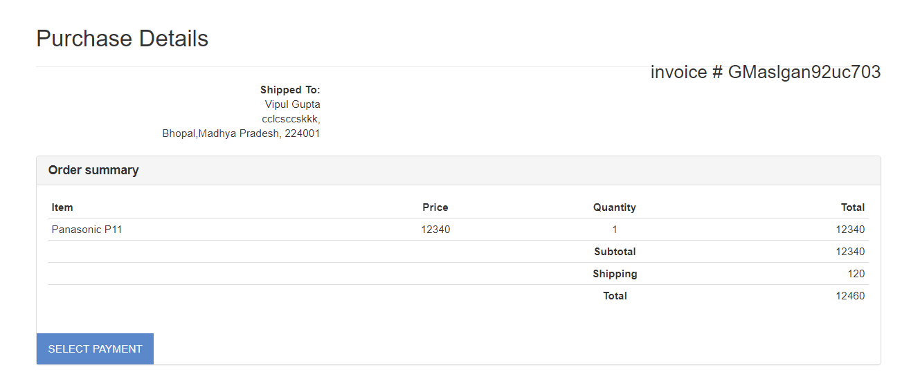

9.Cart Page: This page contains information about the different products that the user has placed in the Cart and he/she can view or delete the products from the cart.

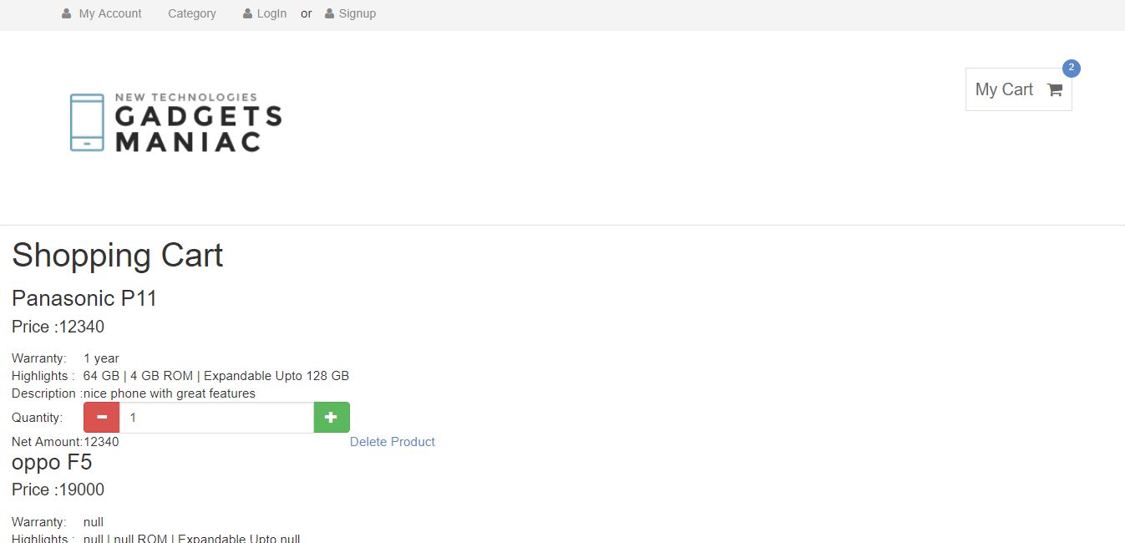

1. My Orders page: This page displays all the orders that a particular user has placed.

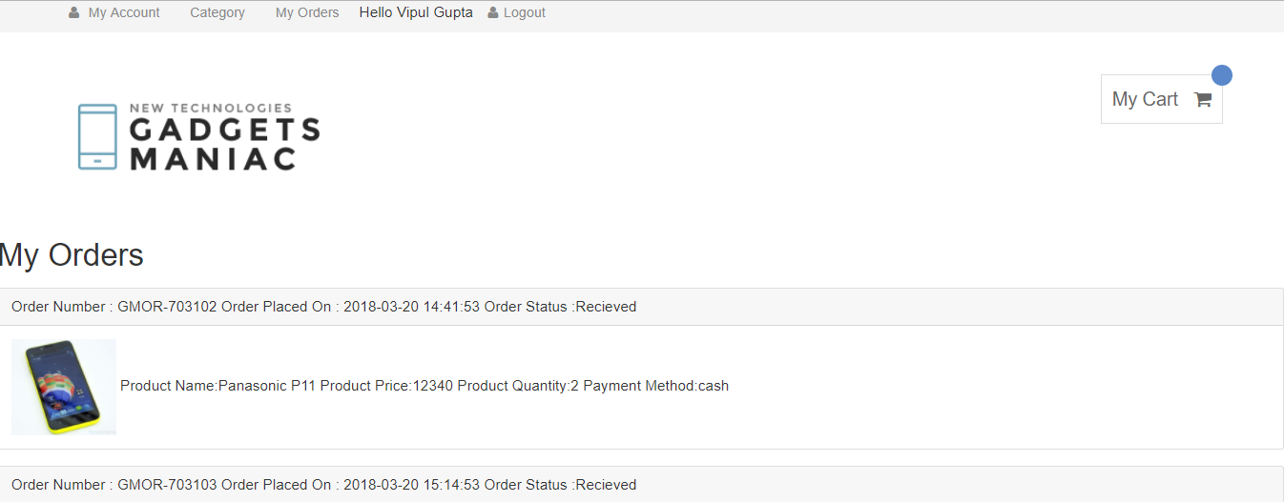

PERFORMANCE & SAFETY REQUIREMENTS:

* The website should let the users see the products even if the user is logged in or not.
* The users should not able to access the specific pages if they are not logged in or they have not sign up.
* Proper authentication should be done when logging in the website.